New Legislation for 2018
By Scott A. Hunter, J.D.

The California legislature has enacted new laws that apply to homeowner associations. This year a few laws were passed which directly affect homeowner associations. These laws are effective January 1, 2018, or are already effective.

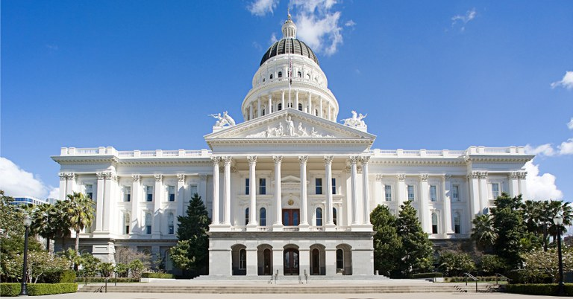

Assembly Bill 634 – Solar Installations on Common Area Rooftops.
This new law revises California Civil Code Section 714.1, Civil Code Section 4600, and adds Civil Code Section 4746. This new law is effective January 1, 2018, and firmly supports solar energy. This law states that homeowners may install solar energy systems in the common area, including on common area roofs. Under this law, owners can install solar energy systems on common area roofs. This applies to condominium associations and other associations with common shared roofs. Additionally, the law states that your association cannot require the approval of other owners before the rooftop or other common area solar installations are approved by your association.
Under this new law, your association must require an owner who is requesting a solar system to notify each unit owner in the building, on which the installation will be located, of the application to install solar on a common area or shared rooftop.
Additionally, your association must mandate that the owner and each successive owner be required to have homeowner liability insurance at all times, and provide your association with a required certificate of insurance within 14 days of approval of the installation, and each year thereafter.
Your association can also require the homeowner to submit a “solar site survey” showing the placement of solar energy systems to determine usable solar roof area. Your association may require that the “solar site survey” be prepared by a licensed contractor or the contractor’s registered sales person. The “solar site survey” must also include a determination of the equitable allocation of usable solar roof area among all owners sharing the same roof, garage, or carport.
Your association may also require that the owner and each successive owner of the solar system be responsible for: (A) the costs for damage to the common area, exclusive use of the common area, or the units resulting from the installation, maintenance, repair, removal, or replacement of the solar energy system, and (B) the costs for maintenance, repair and replacement of solar energy systems, until it has been removed, and for the restoration of the common area, exclusive use of the common area, or the unit after removal. Your association may also require that the owner with solar installation disclose to prospective buyers the existence of the solar energy system of the owner and the related responsibilities.
In addition, this new law clarifies that an association has the authority to impose other reasonable rules. Some additional rules to consider include requiring the owner to sign an agreement which can be recorded in the office of the recorder. This will help notify future owners of the solar installation and make them legally responsible for the solar installation, maintenance, and damage.
Now is the time to update your rules and regulations regarding solar installations. If reasonable solar installation rules are not in place, it may create confusion and liability for your association.

Senate Bill 407 – Political and Non-Commercial Solicitation.
This new law adds new Civil Code Section 4515. This law states that it is intended to:

“. . . Ensure members and residents of a common interest development have the ability to exercise their rights under law to peacefully assemble and freely communicate with one another and with others with respect to common interest development living or for social, political, or educational purposes.”

This law allows members and residents to:
(A) Peacefully assemble or meet with members, residents, and their invitees or guests for the purpose of discussing common interest development living, association and public elections, legislation, initiatives, referendum, or recall processes;
(B) Invite public officials, candidates for public office, or representatives of homeowner organizations to meet with members, residents, and their invitees or guests and speak on matters of public interest;
(C) Use common area, recreational halls, clubhouses, or individual homes to meet for the purposes of (A) and (B) above;
(D) Canvas and petition the members, the association board, and residents for the activities described in (A) and (B) above;
(E) Distribute or circulate, without prior permission, information about common interest development living, association and public elections, legislation, the initiative, referendum, or recall processes, or other issues of concern to members and residents.
This new law allows non-commercial, political, and similar activities to be conducted in your association’s common areas and within the homes in the development.
Members or residents may not be required to pay a fee, make a deposit, obtain insurance or pay insurance premiums in order to use the common area facilities for meetings as discussed in this new law. A $500 penalty can be imposed against associations for each violation of this law.

Senate Bill 2. $75 – Additional Recording Fee
This law adds new Government Code Section 27388.1. This law is effective January 1, 2018. This law creates a new mandatory $75.00 fee when recording most documents in the county recorder’s office. This $75 fee applies to liens, lien releases, abstracts of judgment, etc. This fee can be passed onto the delinquent owner. The $75 fee will also apply to the recording of new CC&Rs, as well as most documents recorded by your association. The new law is to raise additional funds for affordable housing.

Assembly Bill 1412 – Mixed Use Liability Protection
The first part of this law amends Civil Code Section 4041 to provide that if an owner fails to state which address or addresses notices from your association are to be delivered, then your association may send notices to the last address provided in writing by the owner (or if none was provided, then to the property address).
Additionally, this law amends Civil Code Section 5800. Under the prior version of law, volunteer officers and volunteer directors, in residential common interest developments, received some protection from liability. Generally, volunteer officers and directors are not personally liable for claims or lawsuits which are above the limit of your association’s officers and directors policy, if all of the following conditions are met: (1) the officer or director was acting within the scope of his or her duties; (2) the officer or director was acting in good faith; (3) the officer or director was not willful, wanton, or grossly negligent; (4) your association has both general liability insurance and officers and directors insurance, at the minimum required amounts. Under this new law, the protections now also extend to mixed use developments (developments that are both residential and commercial in nature).

Note: Most of the laws in this newsletter apply only to common interest developments (“CID”). If your association is not a CID, then the laws discussed herein may not apply to your association. This newsletter does not constitute legal advice. For specific legal issues, please seek legal advice from your association’s lawyer.

