Amending and Rewriting CC&Rs
By Scott A. Hunter, J.D.

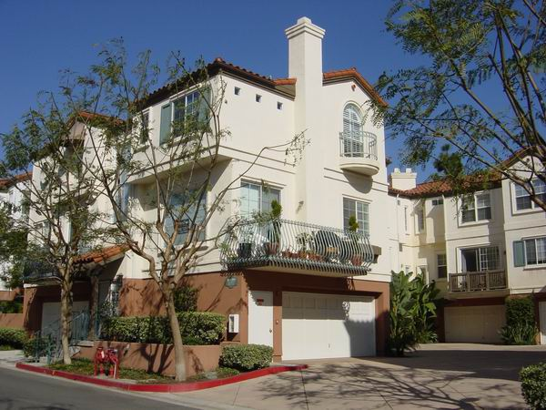
How Old Are Your CC&Rs? Do your CC&Rs still give your association the guidance needed to manage your association? Outdated CC&Rs may be in conflict with current laws and practices, forcing boards of directors to constantly seek legal counsel as to whether certain provisions are still valid or enforceable. Such obsolete CC&Rs offer owners and boards very little guidance as to what should be done in day-to-day and critical situations. This newsletter will help you determine if your CC&Rs should be updated, amended or completely revised.

Statute Law Changes. The California Legislature has enacted many new laws over the last several years which supersede older CC&Rs provisions. These laws directly affect your CC&Rs and your association. The Davis-Stirling Common Interest Development Act (“Act”) was enacted by the legislature in 1984, creating and organizing an entire body of law which directly impacts owner associations. Since 1984, the Legislature has continued to do what we elected them to do—legislate by creating more laws. New laws are added to the books each year.

The Davis-Stirling Act was recently completely renumbered with some other changes throughout. Now would be a good time to amend your CC&Rs to be up to date with the new Davis-Stirling Act.

In addition to the Davis-Stirling Act, there have been significant revisions of other state and federal laws. For instance, the Federal Telecommunications Act of 1996 supersedes all CC&Rs in the area of satellite dishes. Any outdated CC&Rs should be revised to comply with this Federal law, yet allow the association to retain some control over the installation of satellite dishes.

Another example is a newer law which changes the way CC&Rs can be enforced. Under this new law, an association and an owner must attempt to resolve certain disputes before a lawsuit is filed. These new statutes supersede outdated CC&Rs, which should be amended or revised to conform to the new laws.

Case Law. Many court cases have reviewed the workings of associations and have provided guidelines as to what to expect in the future when interpreting certain provisions of your CC&Rs. This court guidance should also be integrated into your CC&Rs.
Practices of the Association. Many of your association’s practices have likely changed since the time it was created, such as the handling of insurance deductibles. Insurance deductibles have increased dramatically in order to help reduce the annual insurance premiums. Who pays this ever-increasing deductible? Are your CC&Rs clear on this point? CC&Rs are often silent or unclear on the issue. Do your CC&Rs allow your association to reduce the number of its insurance claims by providing the option for your association to pay an insurance claim instead of submitting it to the insurance carrier for payment?

Clarify Maintenance Responsibilities. Who is responsible for what? Does your association maintain the balconies, or are balconies the responsibility of each owner? Is the balcony deck actually a roof that your association must maintain? Is the drywall part of the unit, and therefore the responsibility of the owner, or is it part of the common area? Who is responsible for the mold? Your CC&Rs should address and clarify all of these issues.

Stronger Enforcement. Do your CC&Rs allow your association to suspend an owner’s pool and clubhouse
privileges if the owner fails to pay monthly assessments or is violating other rules? Some communities are
experiencing problems with difficult tenants. Most CC&Rs can be strengthened to have greater enforcement options against non-complying tenants and their owners.

Discriminatory Language. Do your CC&Rs contain language that has now been determined to be illegally discriminatory? Discriminatory language includes not only age, gender, and race, but also less-publicized discrimination based upon familial status (discrimination against children), etc.

Removing Irrelevant Language. Original CC&Rs often contain language regarding the developer or “declarant” of the project, giving the developer extra voting power, advertising rights, etc. When the developer is no longer involved, this language becomes obsolete and should be removed. Some original CC&Rs also contain language about adding or “annexing” more land to the project. If this is no longer applicable, then this language can also be removed.

Responsibility for Water Damage. Today, water damage can be the catalyst for very large and contentious disputes. Who is responsible when the upstairs owner’s washing machine hose breaks and floods the downstairs unit? An owner’s own insurance policy will often deny the claim and force the association to fix the damage or submit its own insurance claim. Ambiguous CC&Rs should be revised to clarify who is responsible for water damage.

Security. Courts have held associations liable for harm caused to owners by criminals because of lack of adequate security. Courts have also found that an association can reduce liability for such criminal conduct or lack of security if the proper language is in the CC&Rs.

Neighbor-to Neighbor Disputes. Many issues that arise in associations are best handled between the disputing owners. These issues often include barking dogs, loud parties, trees hanging over one patio to the next, and other issues. The CC&Rs can be amended to give your board the authority to let the disputing owners work out their problems without direct involvement of your association, saving time and money. If the problems include a CC&Rs violation, then the owners can enforce the CC&Rs against the other owner without involvement of your association. Such an amendment will save the precious resources of your association and will let your board concentrate on problems that affect most or all of your community.

Election Changes. Your association’s bylaws can be changed to eliminate the annual meeting or eliminate any quorum requirements, thereby saving your association’s precious resources. Often, too few owners attend the annual meeting for a quorum, so another meeting must be called with time, money and other resources wasted.

A Complete Document. CC&Rs should be complete, consistently providing accurate guidance whenever consulted by your association. Reliance on outdated documents will often create confusion and lead your association down the wrong path. Ideally, CC&Rs should be reviewed for major revisions every 8 to 10 years, or sooner if there are significant changes in the law. The CC&Rs should not be stagnant, but should be a living document which provides flexibility and revitalization for your community.

The Amendment Process. Most CC&Rs can be amended by 51%, 67% or 75% approval of the owners. For those associations with an approval requirement of 67% or 75% (called “super majority”), the courts can provide assistance in amending the CC&Rs after a failed attempt to do so. In some circumstances, it may also be necessary to obtain City or County approval for certain amendments. Your association should seek legal counsel to determine if anyone other than the owners must approve amendments to your CC&Rs.

Typically, your association should give owners 30 to 90 days to return ballots. If not enough owners are returning ballots, then your association will have time to resend ballots to owners who have not responded.

Rewriting Pays for Itself. Rewriting CC&Rs may pay for itself and actually give your association a financial boost and allow your association to more than recoup the costs associated with rewriting your CC&Rs. Most older CC&Rs cap the interest charged on delinquent assessments (dues) at 6% per year and set an artificially low late charge of $5.00. Current laws allow the CC&Rs to be revised to increase the interest rate charged on delinquent assessments to 12% per year and the late charges can be increased to $10.00 or 10% of the delinquent assessment, whichever is higher. These changes may offset the costs of rewriting the CC&Rs and may also help to place your association in a better financial position.

Amending Other Documents. It may be helpful to amend the bylaws, rules and other governing documents of your association along with the CC&Rs to ensure these governing documents do not conflict with each other. Legal counsel can advise you in this area.

For information on amending your CC&Rs or Bylaws, please call us at (877) 322-0410, or email us at shunter@hunterlaw.net.

